Ideation Phase
Define the Problem Statements

Date | 15 February 2026
Team ID | LTVIP2026TMIDS81736
Project Name | LearnHub: Your Center for Skill Enhancement
Maximum Marks | 2 Marks

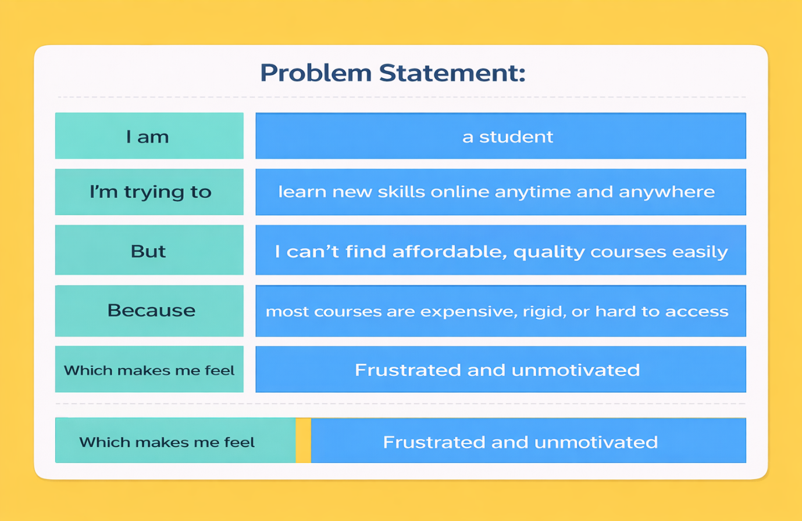
Problem Statement -1:

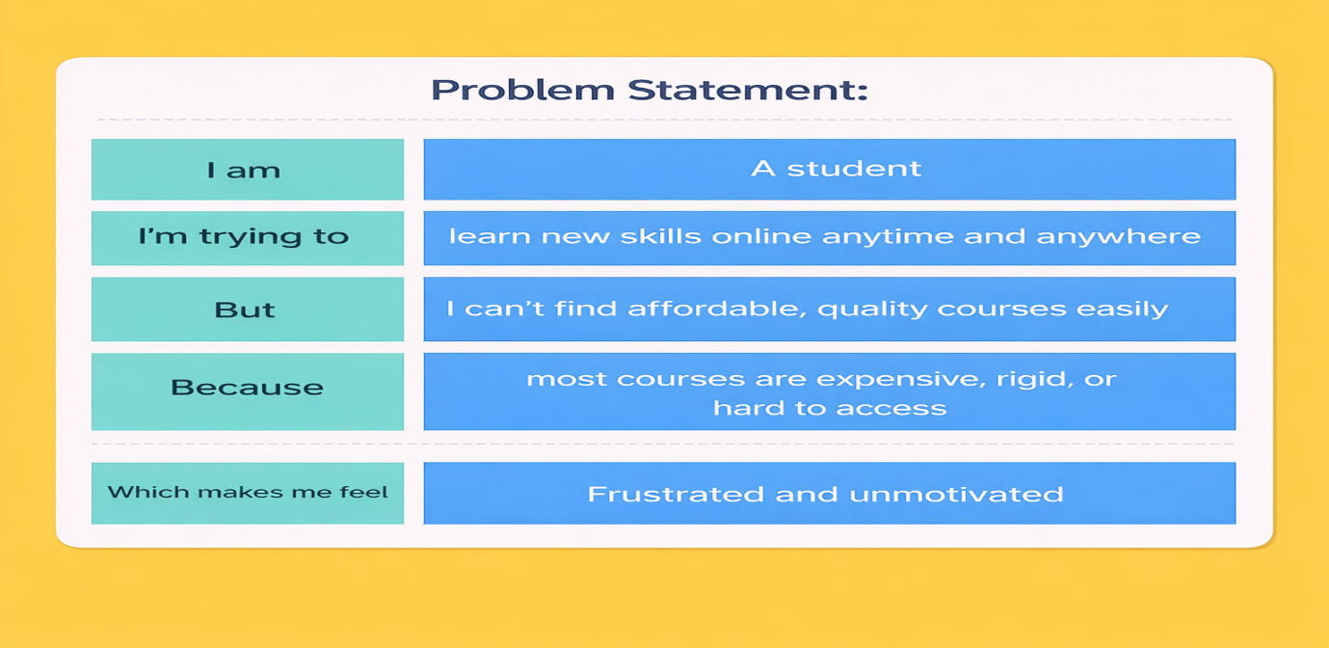
Problem Statement -2:
Problem Statement (PS) | I am | I’m trying to | But | Because | Which makes me feel
PS-1 | A student | Find and enroll in suitable courses quickly | I cannot easily identify the right courses or track my learning progress | Learning resources are scattered across platforms and lack personalization | Confused and unmotivated
PS-2 | An instructor | Manage my courses and student engagement efficiently | Student queries, assignments, and progress tracking are difficult to handle in one place | There is no centralized system for course management and analytics | Overwhelmed and disorganized

